Name: Date:

APWH9, Rerick Period:

**Do Now:** Please draw your attention to Mr. Rerick’s stunning artwork on the board.

| * Based on yesterday’s conversation define:   **Context:**  **Bias:**  **Shared Ideas:** |
| --- |

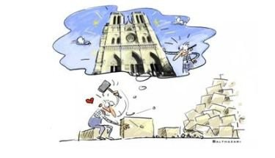

**TWO MINUTE REVIEW**- Open your document from yesterday to review your notes about your story and prepare to present to your groupmates.

**Three Minute Presentations**

As your peers share their (hi)stories, label your group map with locations that are relevant to your stories, and take notes on their “why”

| Peer Name:      Peer Name:      Peer Name: |
| --- |

**Group Work**

Despite each of your unique, individual stories, what commonalities did you find between your 5-6 stories? Record a list with your group (think thematically).

|  |
| --- |

**Excerpt from podcast *Throughline:* “A Story of Us?”**

By Ramtin Arablouei & Rund Abdelfatah

“One of the things Tamim Ansary argues is that human beings need to agree on a common story, a feeling of being part of a *“we”*, or in his words, an intertangled spaghetti of human lives, in order to function. But who decides who the *“we”* is, and what *“we”* can all agree on? If the old narratives have lost their power, who determines a new one? …. Who's being included in the narrative of human history? Who feels included in that story? And how we connect through a mutual understanding of what *was* and what *is*.”

**Questions to consider and discuss:**

1. From your past study of history, who has typically decided who the “we” is in the study of history? Who has typically been included in the narrative?
2. After completing today’s activity, do you think it is possible for humans to have a mutual understanding of the “(hi)story of *us”*? As in, a story that the collective can all agree on or, at least, accept?